Planning for the 2026 Vintage Week is well underway. Now in its 58th year, it remains one of the longest-running community and arts festivals in the country.
Thank you for your continued support. The festival is a special time when we come together to celebrate and enjoy Birr’s rich culture and heritage. While it is supported by the Arts Council, Creative Ireland, Offaly County Council, Birr Municipal District and Offaly Local Development Company, ongoing local investment is essential to secure and maximise these funds. This shared support, alongside significant volunteer effort, underpins the festival’s success, and we invite you to contribute to this year’s event.
Last August, 6,000 people attended the Vintage Sunday Parade, with over 20,000 enjoying events across the week. Many say more people return home for Vintage Week than at Christmas. This generates a strong economic impact and positive regional and national coverage, estimated at €200,000.
Your sponsorship helps sustain the festival and ensures Birr continues to thrive as a place to live, visit, and do business. Thank you again—we look forward to working with you this year.To ensure your inclusion in our Printed Festival Programme, please submit by Friday June 5th 5pm.
We are very pleased to offer a simple to use online payment through our website at www.birrvintageweek.com
We will email you a direct link, making it quick and easy to access and complete your payment

If you would prefer to pay by cheque, please make cheques payable to Birr Vintage Week & Arts Festival. ℅ Birr Theatre & Arts Centre, Oxmantown Mall, Birr and include your details in the tear off form at the bottom of the reverse of this letter.
For queries, please email vintageweeksponsorship@gmail.com

Your Invitation to Invest | Sponsorship Opportunities

Diamond Sponsor  €1500+ | - Your company logo will be given priority placing on the Festival Programme and priority placing on www.birrvintageweek.com (linked to your site)  - Photo Opportunity at a Festival or Business Premises connected to dedicated event  - Promotion of your business through Festival on Facebook & Twitter  - Brand A Barrier - Enjoy priority branding of your business at major outdoor Festival events  - Invitations extended to the Festival Press Launch, Parade Grandstand, Exhibition openings  - Complimentary tickets offered for several limited Festival events
Platinum Sponsor  €750+ | - Your logo will be listed on the Festival Programme and listed on www.birrvintageweek.com  - Promotion through Festival Facebook & Twitter  - Brand A Barrier - branding of your business at major outdoor Festival events.  - Invitations extended to the Festival Press Launch, Parade Grandstand, Exhibition openings  - Complimentary tickets offered for several limited Festival events
Gold Sponsor  €500+ | - Your logo will be listed on the Festival Programme  - Promotion of your business through Festival on Facebook & Twitter  - Invitation extended to the Festival Press Launch & Exhibition openings  - Complimentary tickets offered for several limited Festival events
Silver Sponsor  €350+ | - You will be listed as a Silver Sponsor on the programme  - Promotion of your business through Festival on Facebook & Twitter  - You will be invited to the Festival Press Launch, a major part of our publicity campaign in the lead-up to the festival
Bronze Sponsor  €125/€100 | - You will be listed as a Bronze Sponsor on the programme  - You will be invited to the Festival Press Launch, a major part of our publicity campaign in the lead-up to the festival

Please tear off this portion for cheque sponsorship and return to Birr Theatre & Arts Centre, Oxmantown Mall.
…………………………………………………………………………………………………………………………………………………………………………………………………………………………………………………………………………………………..
Name to appear in programme
Contact Name
Contact Address
Email address
Phone
Sponsorship level/ amount

Yours sincerely, 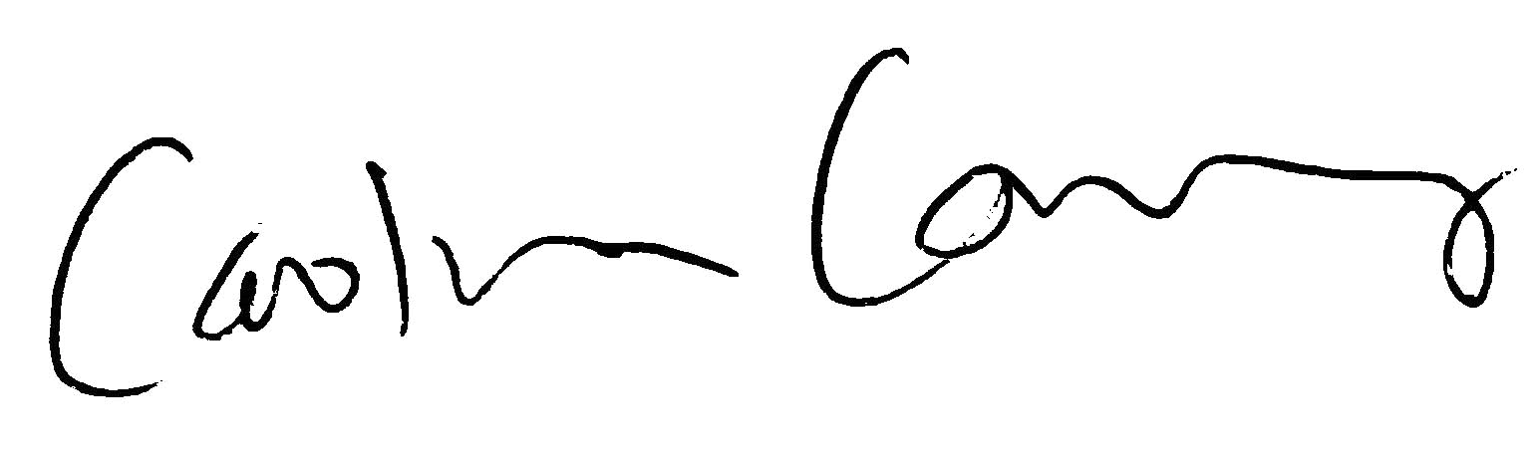Festival Co-Chair

